EWB-MJCET

Chapter Vision:

To utilize the engineering skills to its maximum potential for the development and benefit of the society.

Chapter Mission:
- To harness the resources available
- To develop a database for emerging sustainable and innovative technologies
- To create awareness among student members to work towards development of the society

Our Projects
There are many projects that EWB-MJCET chapter has done and some projects are under progress of completion. To its credit the Projects which EWB-MJCET chapter has finished are listed below.
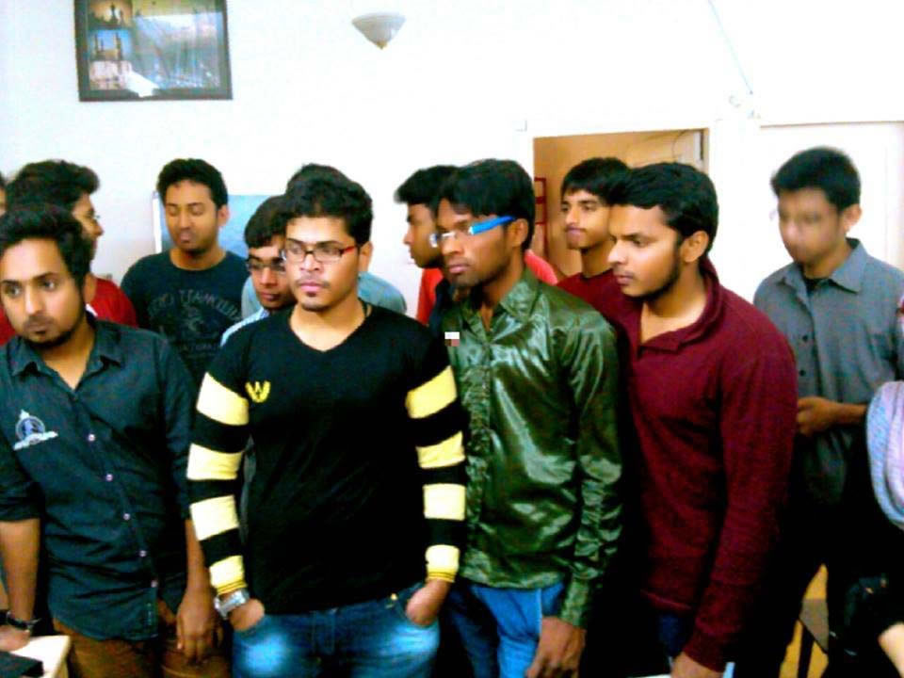
MJCET student chapter sourced bus route information and geocoded the bus stop locations in Hyderabad Metropolitan Area using QGIS software. The data gathered by us filled a crucial gap in the databases. This data is expected to lay the foundation for a much better understanding of transit problems in Hyderabad.
1.Hyderabad Urban Labs Project
This project is a unique voluntary citizen mapping initiative in Hyderabad, taken up by Hyderabad urban labs (HUL) along with EWB-MJCET chapter, it is a multi disciplinary research programme supported by the Right to the City Foundation for a period of 1 week in November-December 2013. EWB-
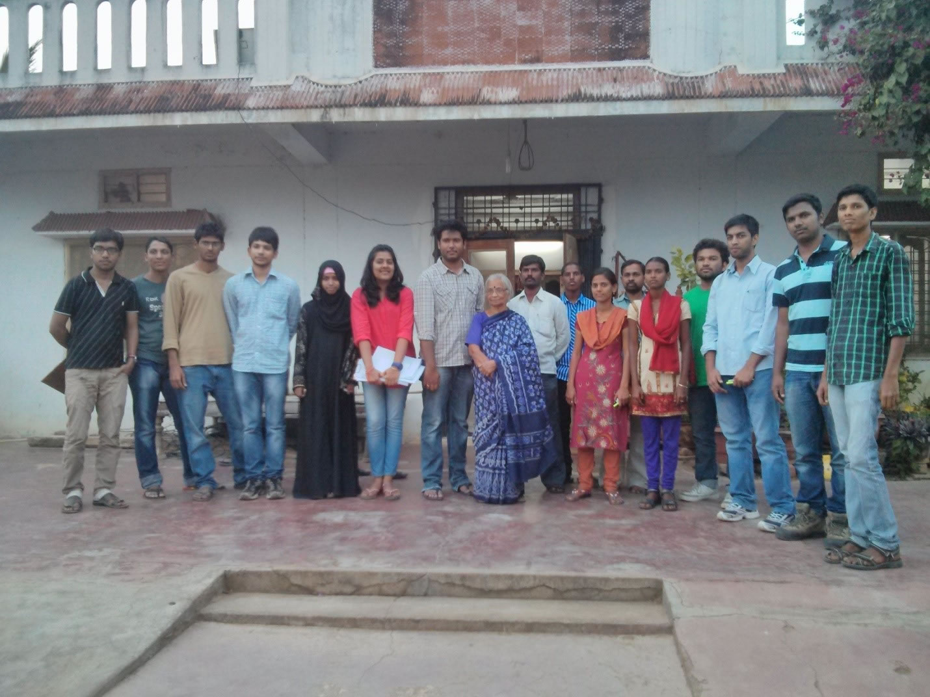
2.Burgula village project (phase-1 completed) || 18 January 2014
Burgula Village, Mahaboobnagar was decided to be developed by EWB- India and Pragathi Welfare Association, and EWB MJCET has lent its part to the development of Burgula Village by volunteering to do the need assessment survey and give research solutions to their problems. EWB- MJCET visited the Burgula Village and performed the need assessment study of 500 houses with a team of ten students in a single day with tremendous efforts. The data collected, interpreted the needs of the village. The data obtained is compiled into a soft copy for future usage. The next phases will be commencing through the intervention of pragathi welfare association.
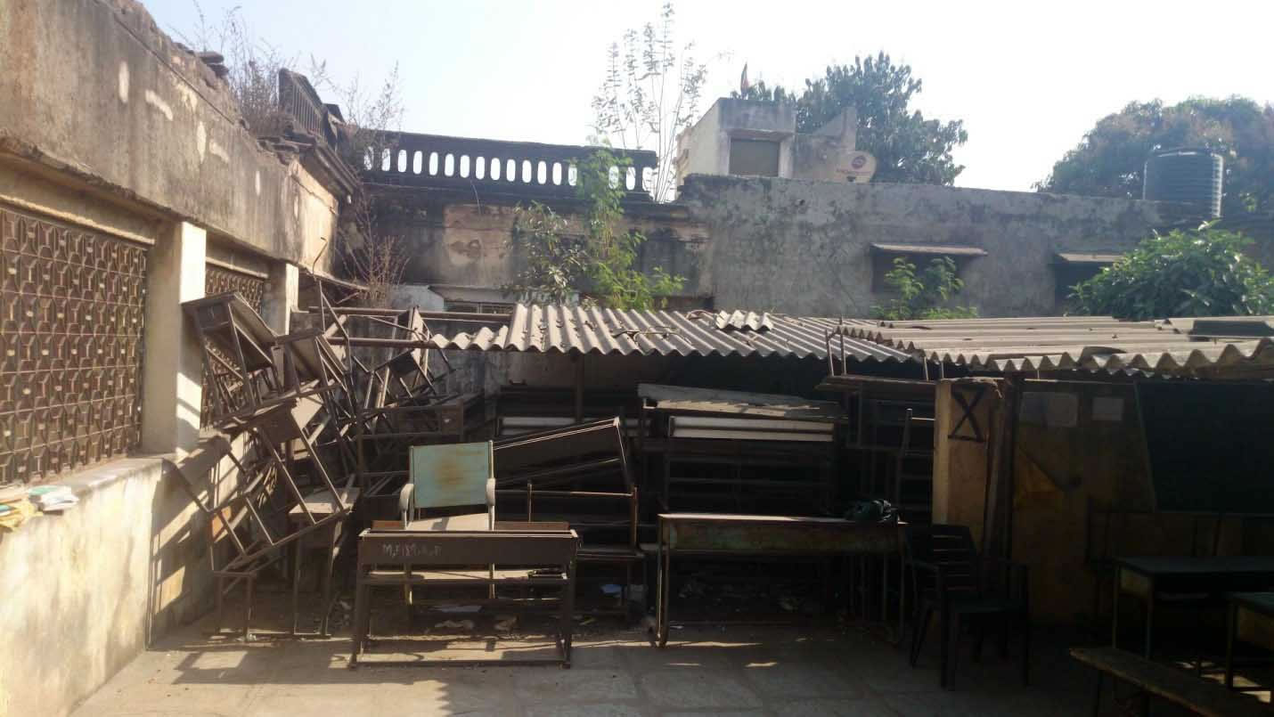
3.School project survey || 5th February to 15th February 2014
By the inspiration imparted by Dr. Ashok Agarwal Sir, EWB MJCET, has taken up initiative to improve the conditions of poor Govt. Schools. There are many schools, in which students lack the basic requirements. EWB- MJCET has taken up this task as a challenge. Though it is cumbersome, we are successful in creating a database of such schools by travelling round the city and with the help of media. The schools which are most in need will be short listed and will be developed in the next phases.
4.Construction of EWB MJCET office|| 26th March
In the event of felicitation of Ex Office bearers, Engineers Without Borders (EWB) M.J.C.E.T Chapter proudly announced- its design to build, one of a kind self sustainable -eco friendly building within its college premises. The structure would act as an official building for the M.J.C.E.T chapter and would also facilitate meetings between the cabinet member and students. The foundation stone has been put down. The project is inaugurated by Dr. Ashok Agarwal, Chairman, Engineers Without Borders (EWB) India. The project would be collectively funded by our college and EWB- India. The design, construction and implementation will go hand in hand with the motto of the chapter, i.e.To provide a sustainable solution to a social problem. This project would act as a yardstick for the future students and other student bodies to build a self sustainable building.
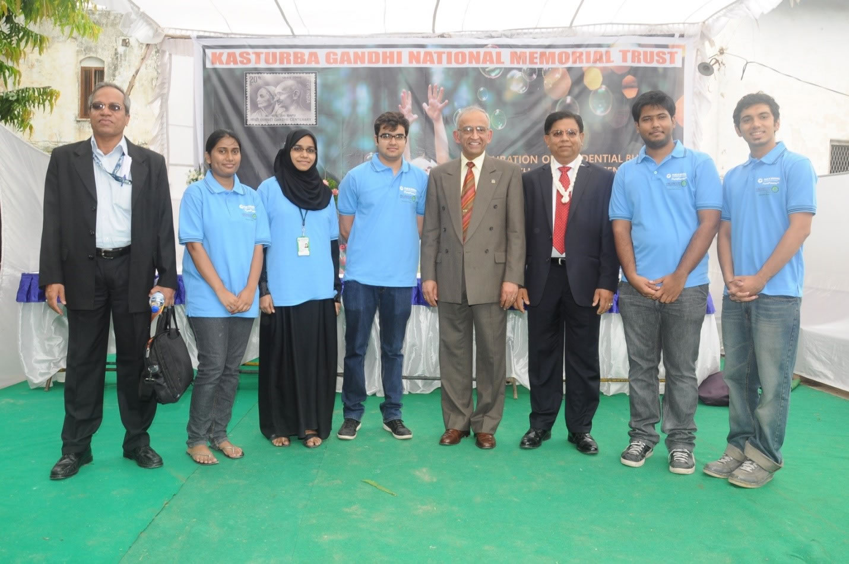
Photograph of Students of Muffakham College Chapter with Dr. JayanthSabnis, Vice- President, Engineering Module, Pratt and Whitney Aerospace, USA and Shri. Mahesh Patel, Engineering Global Sourcing, Pratt and Whitney Aerospace, USA
5. Kasturba (KGNMT) Project || (March-August)
Kasturba National Memorial Trust is a place for dejected and underprivileged women. The conditions prevailing at the trust were very poor. They lacked basic facilities like residential shelter and roofing, bathrooms etc. This project was to build a residential construction to the inmates of kasturba trust. Pratt and Whitney Aerospace, USA, BELCAN, MTC, UTC, Cyient and their allies came forward with a large donation of $120,000 which comes to 68 lakhs(INR). We could successfully build an two storey building equipped with E-Learning Centre, Play ground, Bunker Beds, Water Harvesting System, Solar Water heater. Our students could focus on various aspects starting from the Syllabi for E learning Center, Designing the play ground area, analysis of water heating requirement and make it a success.
Engineers Without Borders student chapter of Muffakham Jah College of Engineering and Technology have shown their passion towards the development of women of Kasturba Gandhi National Memorial Trust, Bandlaguda, Hyderabad with their engineering skills. We could support this development project funded by Pratt and Whitney Aerospace, USA and their allies by taking up the various areas of the projects starting from the development of playground area, E Learning centre to the bed pillows of the inmates of trust.
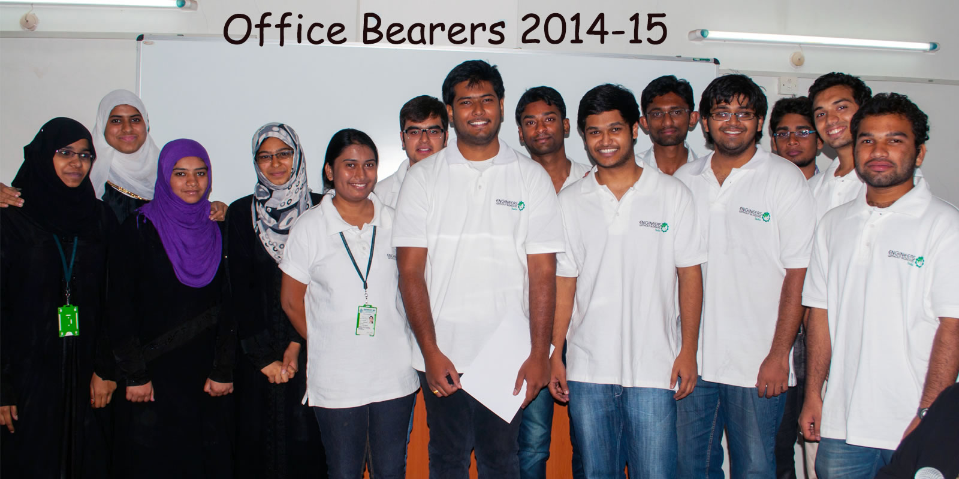
6. Design and Fabrication of Foot Operated Tap: January 2015
This innovation, foot operated tap is an initiative of EWB MJCET to conserve water. This project was collectively executed by ShaikShowkath and Md. Maqsood. This saves about 40% of water compared to regular tap. This systems is cost effective and costs only Rs. 700/-. It is very much helpful for Doctors, Labors etc., who cannot touch the tap with soiled hands. The following project was displayed during the TSE’15 conference
7. Biodiesel- An alternate fuel: February 2015
Members of EWB MJCET Syed Imran, ShaikRauhon Ahmed have come up with a solution to fuel crisis and made bio diesel from plants. It was concluded that fuel generated in all the stages of production has been utilized by some or the other way. This process is about 90% efficient and cost of diesel in bulk production will be Rs.50-55 This project was also displayed during the TSE’15 conference.
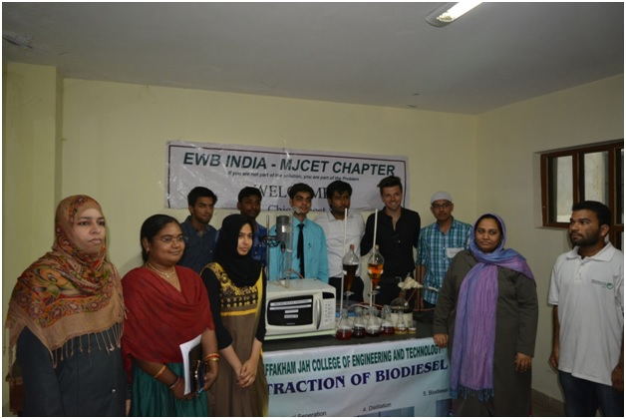
8. Sanitation survey at Musheerabad and Rasoolpura Schools: February 2015
EWB MJCET members formed two teams and visited the two Govt High Schools at Musheerabad and Rasoolpura in association with BastiVikasManch and performed the need assessment surveys at these schools. We have supported the initiative by providing the construction designs for the installation of pipelines and the construction of new toilets at these schools
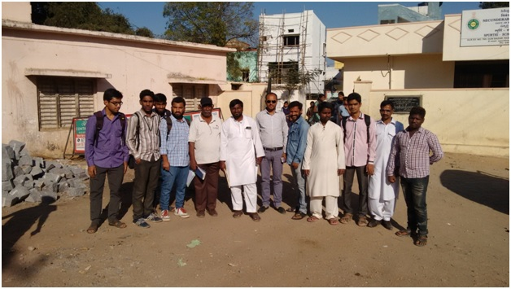
9. School Survey -2: May 2015
In February 2014, Under the inspiration and guidance imparted by Dr. Ashok Agarwal Sir, EWB MJCET launched an initiative to study the conditions in poor Govt. Schools in Hyderabad with a view to improving the condition of some of these schools. Again May 2015, we have surveyed more schools. We have zeroed down to Mahendra Hills school and Erramanzil Govt High school after the survey.
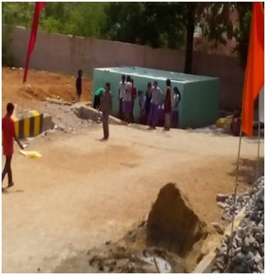
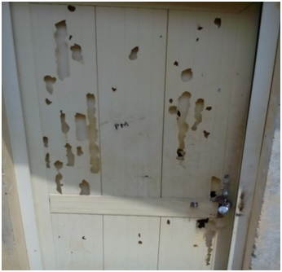
10. KGNMT Kitchen and Bangalore E learning centres: (January-July 2015)
This project is a continuation to KGNMT residential building project (2014). In this project, the focus was to,
- Ideation to provide kitchen and dining hall
- Energizing the E learning center at KGNMT
- Establishing E-learning centres in Bangalore
- Landscaping at KGNMT and Playground Development
- Survey for feasibility of water harvesting
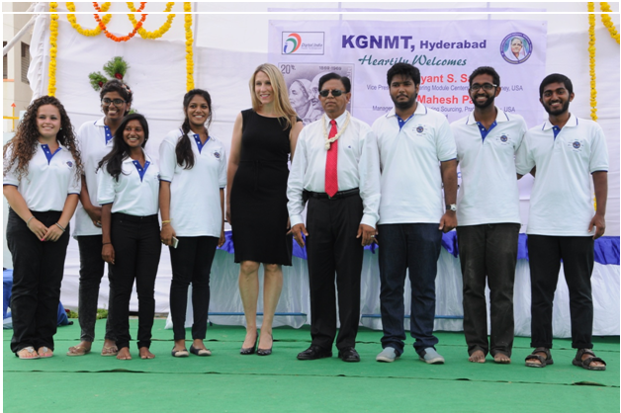
11. Adoption of Government High School: September 2015
As per the School survey -2 conducted in May 2015, EWB MJCET initiated the adoption of school project at Govt. High School, Erramanzil, Hyderabad which has a strength of about 524 students with majority girls. It did not have proper black boards, drinking water facility and internal roads. We focused to provide water facility, sanitation facilities, and development of playground, plantation, and repair of black boards. 55 Students belonging to EWB-MJCET conducted the survey and found out the problems in the school. Different teams were formed to resolve various problems in school. The team provided clean drinking water, hand wash with foot operated tap, repaired black boards, made an walk way to enter the school, supplied E - learning materials, improved the play area, conducted plantation drive and conducted Swatch Bharath campaign.
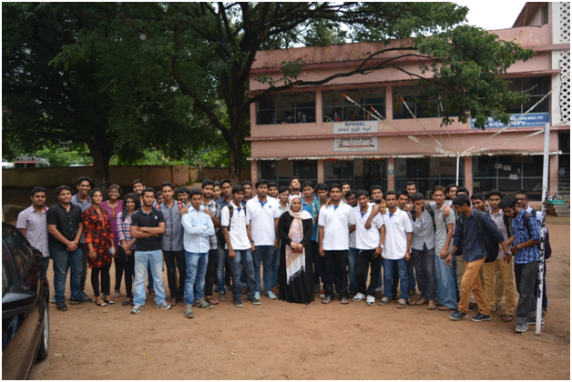
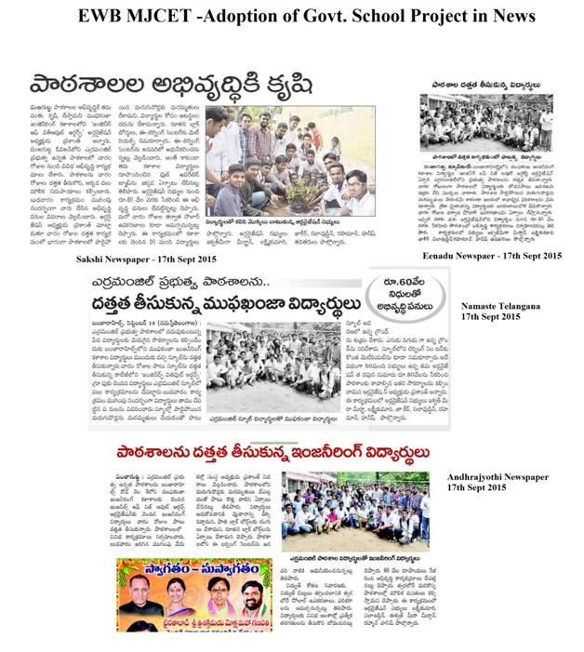

ACTIVITIES

ducation through paper donation: July 2015
EWB MJCET has organized an paper collection drive at college and collected about 300 kgs of used books and paper waste. This materials is donated to “NachiketaTapovanVidyamandir” which sells them to ITC ltd. and funds poor students for education.
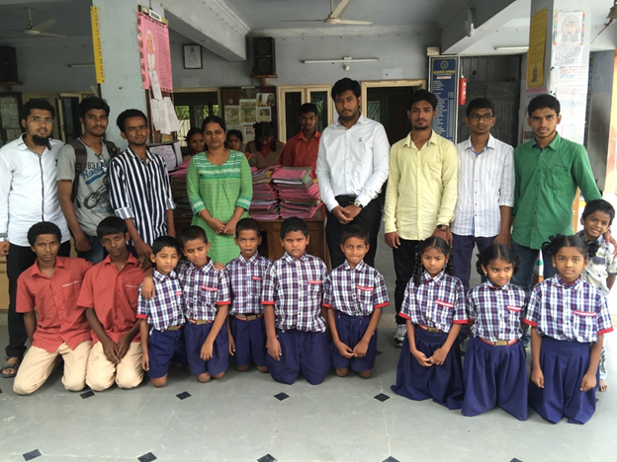

Industrial Visit: Thrive Solar Energy Pvt. Ltd.: August 2015
THRIVE® SOLAR ENERGY PVT. LTD., is an independent renewable energy solutions and technology provider focusing primarily on the solar photovoltaic applications and has built a significant track record in implementing solar projects world-wide.
A team of 52 students along with 4 faculty members visited the industry to find out about the work done by the thrive solar company in terms of banishing the darkness from the homes of poor off-grid families, and to seek the knowledge about the working of solar power system. A survey was done in different sections of the company like assembly section, production section, lamination section and roof top of the company where the solar panels were placed and it served for 70% of power supply to company.
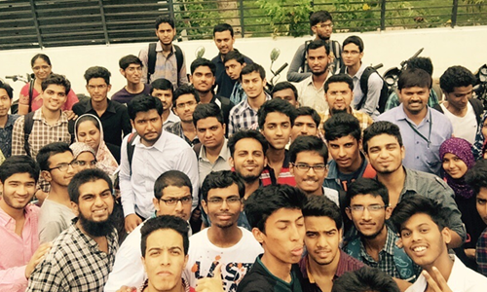
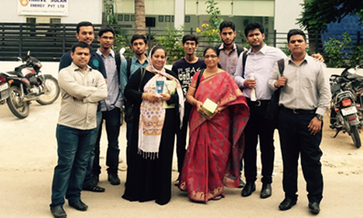

Airtel Hyderabad Marathon : August 2015
The Airtel Hyderabad Marathon is the second largest city marathon in India.
The 2015 Marathon is their 5th edition and is organized by the Hyderabad Runners Society, a non profit organization founded in 2007 to encourage active and healthy lifestyle among all age groups in the cities of Hyderabad and Secunderabad.
So EWB MJCET took the initiative to be a part of Airtel Hyderabad marathon. For publicity of the event the posters were posted in the college premises to get more volunteers for AIRTEL HYDERABAD MARATHON.

Volunteers from EWB MJCET:
EWB MJCET was allotted two sections from Nagarjuna Circle to post KBR park with a stretch of about 6 kilometers to control the traffic marshalling and cheering the runners. This time, 67 volunteers have engaged themselves in to the event from EWB MJCET. All the planning for this event started almost one month before. On the day of the event all the volunteers assembled at the respective aid station at as early as 4.30 AM and respective jobs were assigned to them.
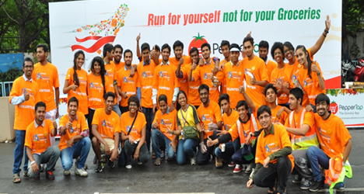
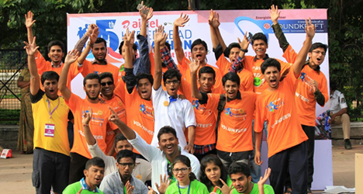
Thus EWB MJCET has played its role to conserve and promote ‘the spirit of running’ through its volunteer support and publicity to the event.

ACTIVITIES
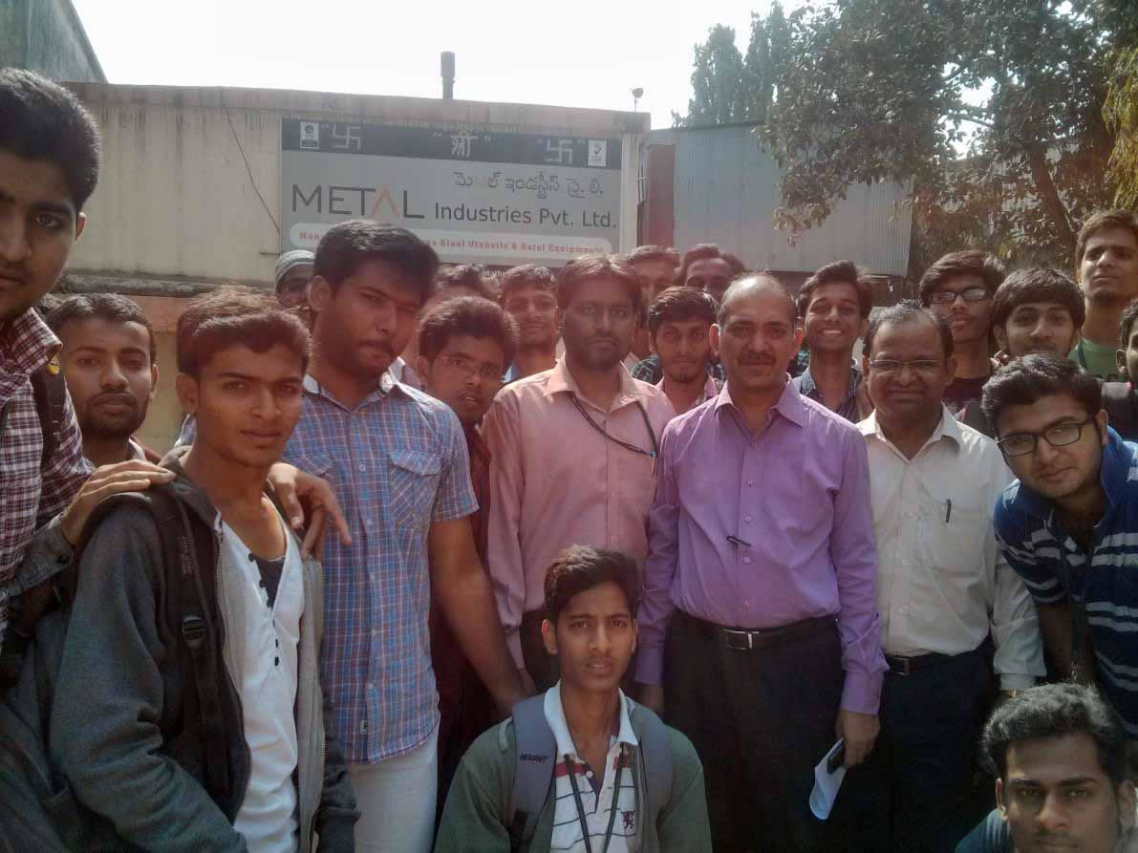
Industrial visit || 3 January 2014
Industry visits sensitize students to the practical challenges that Industries face. Industrial visits also give greater clarity about various concepts for students as they can practically see precision practice. Metal Industries Pvt Ltd, Sanathnagar, Hyderabad, India is a sophisticated Commercial Kitchen Equipments, Refrigeration manufacturer with exclusive marketing units of its own. The more we see, the more we learn; Students in number of 45 from both SAE and EWB participated and observed the techniques used for best designing and Manufacture of various products. They could also see various advantages and disadvantages of using various manufacturing techniques on the Environment.

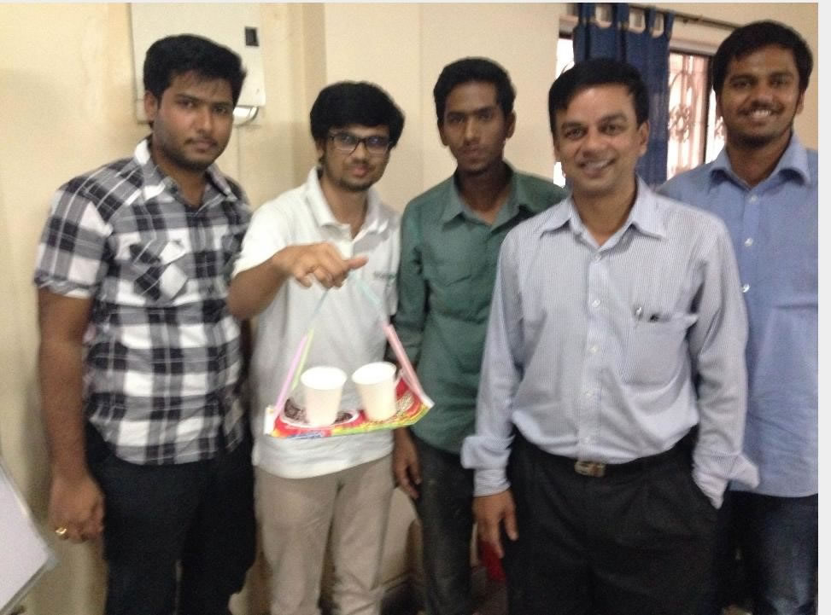
DFX workshop || 6 January 2014
DFX is a philosophy that promotes rapid and successful products. DFX Workshop will provide an overview of how to design and develop mechanical engineering product that is manufacture reliable, usable, maintainable, supportable and also profitable. The acknowledgement of such a philosophy will assist students in their research practices.It is high time that Engineering students start adopting DFX practices and develop world class products. We the students of MJCET with the help of Ravi Taluri Sir who has been keen to share his experience taught us the best design engineering practices on 6th January 2014 at CSIM/ EWB- India office.

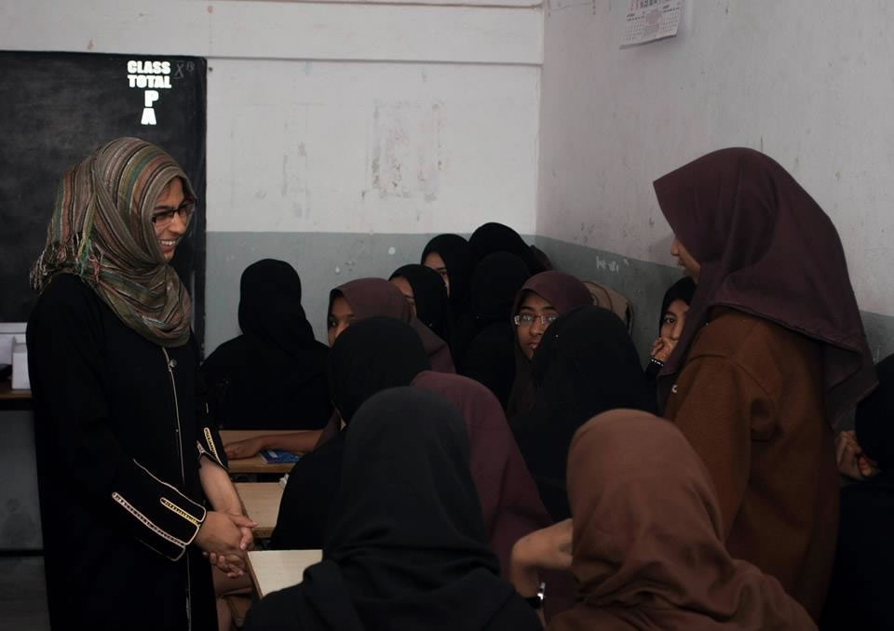
SSR Activity || 15 January 2014
Education is a fundamental human right and vital to achieving economic growth, increasing income, and sustaining a healthy society. Education is important in helping to improve lives, break the cycle of poverty. EWB MJCET is one such chapter which is committed to serve the poor pupils, give them a small moment of joy and learning, and supplement the interest to continue to study by inspiring them. EWB MJCET is committed to ensuring that all girls and boys are able to realize their full potential. We know that children will flourish if they are able to go school, stay there until they finish and learn the basic skills of literacy, mathematics, life skills and critical thinking in a supportive setting. We help them to do this by supporting education initiatives.

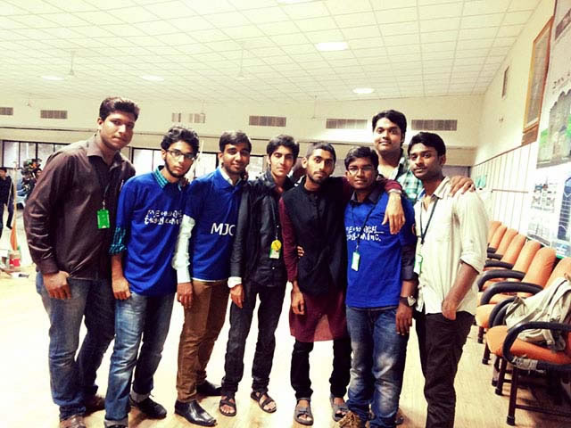
ADSOPHOS 2014 || 6th,7th March
With fund generation as the criteria, EWB- MJCET has organized three in the National level tech-fest at Muffakham Jah College of Engg. And Tech. conducted on 6th and 7th march. EWB MJCET has organized three events as a part of our tech- fest ADSOPHOS 2014 they are:
1. Modulo Detritus
2. Alpha Coding
3. Mega Pixel
The club displayed its innovative projects in the Tech Expo at the same event.
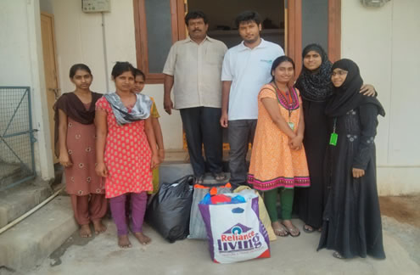
(A group picture of EWB MJCET team members at Kasturba Gandhi National Memorial Trust donating the clothes they collected)
Clothes Collection Drive: 17th April
To extend our hands and buttress the inmates of Kasturba Gandhi National Memorial Trust, Bandlaguda, while working for their development and lending the intellectual services, our project team has contributed to donate them with a few bags of Clothes which are in good condition.
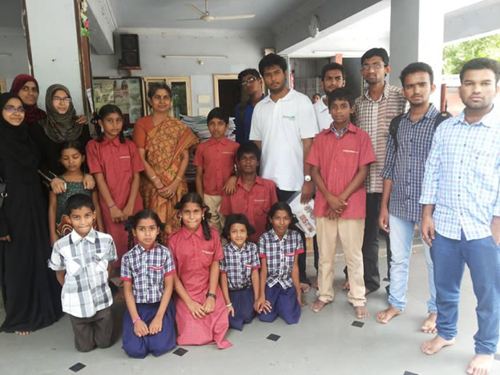
(A group picture of EWB MJCET team at NachiketaTapovan with its school inmates)
Education through paper donation || 2nd August
EWB MJCET Chapter is committed to serve the education of the poor children. It organized an paper collection drive at MJCET and donated the same at NachiketaTapovanVidhyaMandir. The collected books were reused.

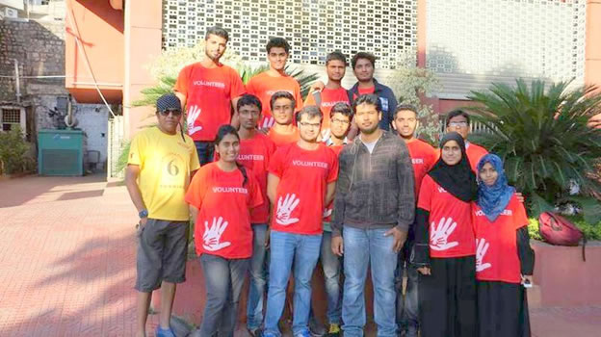
(A group picture of EWB MJCET volunteers with AHM representative)
Airtel Hyderabad Marathon’14 || 24th August
It is one of the prestigious and biggest marathons of India. EWB MJCET volunteered to organize 8 kilometers of it total run with about 50 volunteers. EWB MJCET volunteers showed ultimate unity and utmost passion to support this run.

NATIONAL CONFERENECE ON TECHNOLOGIES FOR SUSTAINABLE ECOSYSTEM
EWB MJCET has structured a national level conference-“Technologies for Sustainable Ecosystem” as an annual event for the chapter. This event will be organized at MJCET annually during the February-March Months.

Conference on “Technologies for Sustainable Ecosystem 2015”
26th– 27th March 2015
EWB MJCET held an conference on “Technologies for Sustainable Ecosytems” in association with various other student chapters of BITS Hyderabad, Gitam University, GNITC and TKREC.
The two day conference was divided into various sessions on how various practices like energy conservation, water conservation, agriculture, green building technologies, problems of society etc are important to the engineers and engineering students. This also had a project exhibition, quiz competitions, cleanliness drive included.
The conference received immense publicity through newspaper media and online partners.
(Dr. Ranganayakulu,CEO,Thrive Solar during his talk with audience)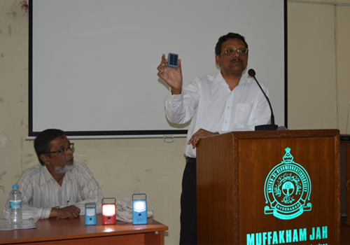
Media Publicity:
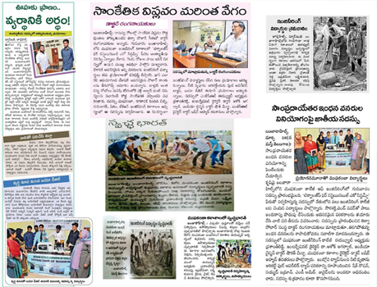
Event Partners:

(Megha Engineering and Infrastructure Ltd.)
Online Partners: YO Grad!

NATIONAL CONFERENECE ON TECHNOLOGIES FOR SUSTAINABLE ECOSYSTEM
EWB MJCET has structured a national level conference-“Technologies for Sustainable Ecosystem” as an annual event for the chapter. As last year, it was also conducted in the year 2016.

Conference on “Technologies for Sustainable Ecosystem 2016”
25th-26thFebruary 2016
EWB MJCET held an conference on “Technologies for Sustainable Ecosytems” in association with various other student chapters of BITS Hyderabad, GitamUniversity,CBIT, GNITC and TKREC.
The conference was divided into various sessions which covered various topics like clean energy systems, ecological engineering, urban sustainability through smart cites and innovations in waste management. It was discussed how the above topics are important to the society and how they could be practically implemented in modern day conditions and situations for the betterment of the society.
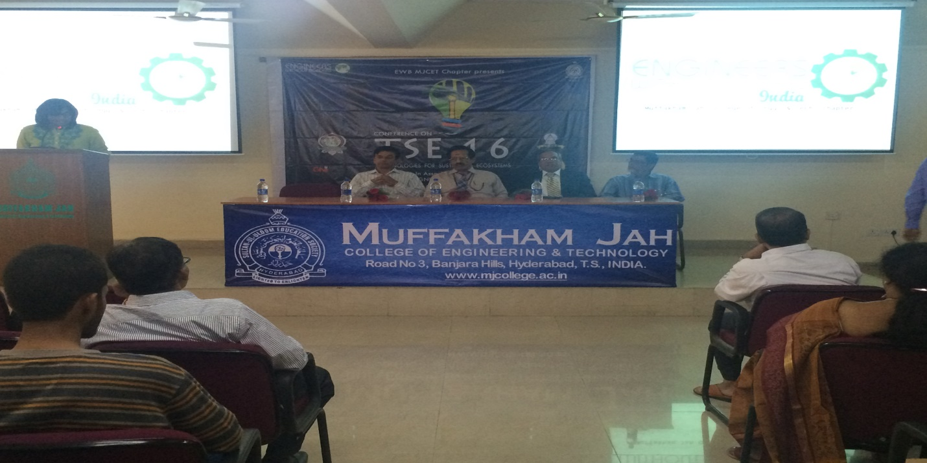

FELICITATION OF EWB-MJCET CABINET 2015-16

On the 30th of July 2016,EWB MJCET conducted a felicitation ceremony where the cabinet members of 2015-16 were felicitated for the immense contributions and hardwork they put in for EWB-MJCET which also embarked the introduction of new office bearers for 2016-17.

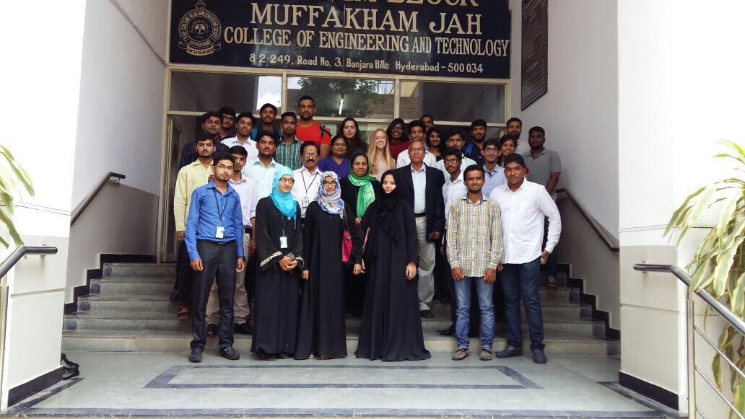

AirtelHyderabad Marathon : August 2016
The Airtel Hyderabad Marathon is the second largest city marathon in India.
The 2015 Marathon is their 5th edition and is organized by the Hyderabad Runners Society, a non profit organization founded in 2007 to encourage active and healthy lifestyle among all age groups in the cities of Hyderabad and Secunderabad.
Even in 2016 EWB-MJCET members volunteered for the Marathon to contribute towards the spirit of running. Around 60 members volunteered for the event and 2 teams of 30 members were allotted on 2 different stations, which were located at Nagarjuna Circle and KBR park respectively. The volunteers had to report on 4:30AM at the day of the marathon where they were assigned different tasks like cheering the runners, collection of waste, providing the runners with refreshments etc.
The marathon was a huge success and received immense media coverage.